IMAT3451 Final Year Project Periodic Progress Report (PPR)

Programme/Course Title: Computer games programming

Name: Connor Rowland Assessment Period: week 8

Project Title: Dobble Report Number: 4

Objectives for Period: (refer to previous report)
Amend networking. Write up packing and complete reading on other areas.

Summary of Progress for Period: (identify evidence of progress)

All complete.

Problem Areas and Suggested Solutions:

Some minor suggested change to the lit review.

Objectives, Deliverables & Plan for Next Period:
Build environment set up: Libraries, VS settings, folder structure, GitHub.
Complete all work for sprint 1 and write units for your random number generator.

Date of Next Review: 1pm 13/12/2018

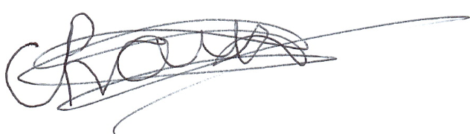
Student’s Signature: Date: 22/11/2018
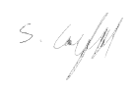

Supervisor’s Signature: Date: 22/11/2018

Comments (if any):

